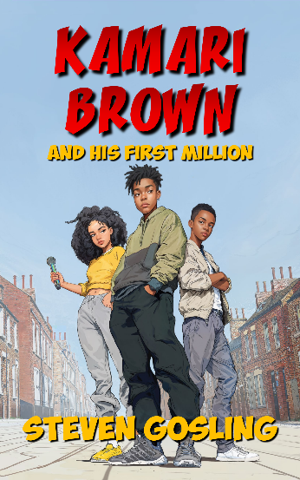  Author: Steven Gosling  Publisher: Secta Publishing  ISBN: 9781068456800  Format: Paperback  Trim Size: 203mm x 127mm  Pages: 266  Publication: 16/09/2025  Price: £7.99  Category: Children's/Teen  General, modern  (YFB)  Humorous stories  (YFQ)  Comps: Steady For This  King Of Nothing     | KAMARI BROWN  AND HIS FIRST MILLION  ‘A boy that’s one in a million’  About The Book  Kamari is a 13-year-old boy, who tries to help his poor family out with get rich schemes, but they get him more trouble than money. Until the track of a best-selling rapper, accidentally gets mixed up with one of his songs, and he becomes the hottest property in music.  Things go great until he finds out about the mix-up. Will other people find out? Will he own up? One thing's for sure; nothing will go as planned.  The book is a MG/teen comedy with a diverse set of characters. Exploring real world issues, and the importance of friendship and family.  About The Author  Steven Gosling, lives in London with his two daughters. He has been writing stories for many years, but he first obtained success as a poet. He won the Jamaica Cultural Development Commission's 'Festival of the Written Word' and was published in the Gleaner. He decided to concentrate on stories, when he couldn’t find the right kind for his children, when they were growing up. Typically, he thought, if they didn’t exist, he would create them.  Selling Points  - The book is right on trend with its themes and plot.  - It has a diverse cast, which is what people are looking for.  - Aimed at children and teens, especially boys.  - influencers on TikTok and Instagram are featuring it.  - Initial reviews are 4 or 5 stars.  - Available in Paperback, ebook and audiobook.  ‘The concept is really funny and the pace is perfect. It kept me hooked throughout the story, with plenty going on. So, it never lagged or felt slow.’  —Author, Stephanie Ward  ‘This book was a cool ride about owning up to your mistakes, chasing your dreams, and learning some tough lessons along the way. I honestly could see this as a Disney Channel Original Movie.’  —Netgalley  ‘This is an entertaining story featuring a lovable rogue main character with a heart of gold. Kamari reminded me of some of the characters I used to enjoy when I was younger, Bart Simpson, Louis Stevens.’  —LoveReading4Kids  Supplier Details  Tony Jones  Secta Publishing  07910 110 301  www.sectapublishing.com  info@sectapublishing.com / sales@sectapublishing.com

