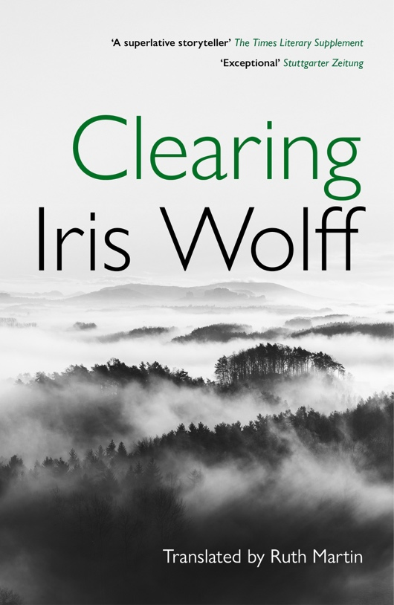 | 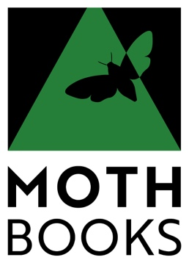  Advance Title Information  CLEARING  Iris Wolff  Translated from the German by Ruth Martin  Edited by Monique Charlesworth  A compelling novel of migration, friendship and memory
Publication date June 4, 2026  Price £12.99, EU €14.99, A$26.99  IMPRINT – Moth Books  RIGHTS HELD – UK and ANZ  ISBN: 9781917593045  BINDING  Paperback  FORMAT  198 x 129mm  EXTENT  204pp | Description  ‘When are you coming?’  Four words on a postcard from Kato lure Lev from the village where both grew up under the harsh Ceausescu regime. When borders opened, the outcast girl could not wait to leave. But Lev stayed behind. He felt bound to their remote village in the Carpathians, to the forest and places that formed him.  Journeying into the past, their relationship unfurls through forgotten incidents, underground resistance, repression and adolescence to their first meeting as children – individual moments that illuminate a life.  Set on the periphery of Europe, this award-winning novel beautifully depicts what it means to belong. A bestseller in Germany, shortlisted for the 2024 German Book Prize.
Fiction: literary, historical, Romania, Germany  Fiction: translated fiction | ‘A great contemporary book’ - Frankfurter Allgemeine  ’The first highlight of this literary year - exceptional' - Stuttgarter Zeitung  ‘A remarkable author’ - Deutschland radio  PRAISE FOR IRIS WOLFF:  ‘a superlative storyteller … memorable prose, subtle and mesmerizing’  The Times Literary supplement  BLURRED by Iris Wolff : ‘the breadth of an epic and the lightness of touch of a fairytale, a pocket history of 20th-century Romania ‘ - The Guardian
 | Born in the medieval town of Sibiu, Transylvania, Iris Wolff emigrated to Germany aged eight; her fiction explores the lost world of her childhood under the dictatorial Ceaucescu regime. She has written five novels and a collection of short stories and won numerous literary prizes and awards. She lives in Freiburg im Breisgau.
ENQUIRIES & ORDERS orders@yps-publishing.co.uk 44 (0) 1904 431213 DISTRIBUTION: Estelle Charles eharmony@yps-publishing.co.uk

