
Advance Title Information

Worlds Apart

Julia Franck

Translated from the German by Imogen Taylor
Edited by Monique Charlesworth

Two Germanies and two different lives are depicted in this powerful Bildungsroman of family, escape and first love, by award-winning Julia Franck.
Publication date February 5, 2026  Price £12.99, EU €14.99, A$26.99  IMPRINT – Moth Books  RIGHTS HELD – UK and CW excl CAN  ISBN: 9781917593021  BINDING  Paperback  FORMAT  198 x 129mm  EXTENT  318pp | Description  Born in East Berlin, Julia is eight when her actress mother uproots her family of four girls, by different fathers, heading West in search of a better life. Their eventual landing in the remote countryside of Schleswig-Holstein solves no problems for this fractured household.  Desperate to escape a childhood of rural poverty, neglect and shame, the lonely child becomes addicted to writing. Aged 13, she leaves her family. At school in West Berlin, she finally encounters love.  In this novel based on her youthful diaries and early life, Julia Franck shows why and how a great writer found her voice.
Fiction: literary, historical, autofiction, Germany  Fiction: translated fiction | ‘Radically personal ... a stirring book in prose that captivates and engages’ (Berliner Zeitung)  ‘This book (in which the characters have the same names as in real life) is truthful by duty and beautiful by choice’ (Die Zeit)  ‘Worlds Apart is a fascinating piece of prose and a rousing story of self-empowerment’ (Brigitte magazine)  ‘This family history hinges like a swinging door on key dates in twentieth-century German dictatorship.' TAZ
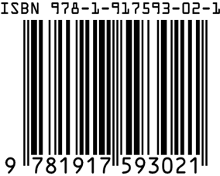 | Born in Communist East Berlin in 1970, Julia Franck is an author and essayist who has published novels and short stories. The daughter of an actress and granddaughter of a sculptor, her powerful novels of family and motherhood draw on her own life across divided Germany as they delve into the nation’s tumultuous past. Two of her novels have been filmed. The recipient of numerous awards, she lives in Berlin.
ENQUIRIES & ORDERS orders@yps-publishing.co.uk +44 (0) 1904 431213
DISTRIBUTION: Estelle Charles eharmony@yps-publishing.co.uk

