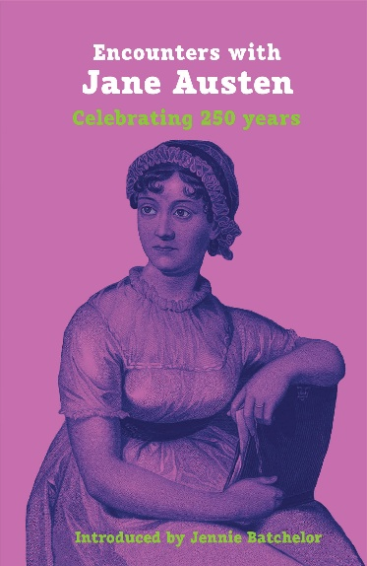
ENCOUNTERS WITH JANE AUSTEN
Celebrating 250 years
Introduced by Jennie Batchelor
- A wonderfully diverse anthology of poems, stories, essays reflecting on the life and work of Jane Austen by new and well-known authors and poets including two Pulitzer Prize winners.
- Overview of Austen’s work and its importance by academic and author Professor Jennie Batchelor
- Contributions from 30+ authors and poets including Bridgerton author Julia Quinn, NY Times bestselling writer Charlie Lovett, novelist and academic Janet Todd, and exclusive interview with the sculptor of new Austen statue Martin Jennings.
- Black and white illustrations from early edition of Pride and Prejudice
- Quotes from the novels and letters by Jane Austen throughout.

About the Book
As we mark the 250th birthday of one of literature’s most beloved author, this highly original collection celebrates the enduring influence of Jane Austen’s works. With an insightful introduction by academic and author Professor Jennie Batchelor, 30 + contributors—including acclaimed writers, scholars, and artists—share how Austen’s timeless storytelling has shaped their own journeys.

A heartfelt tribute to the writer whose wit, wisdom, and charm continue to captivate audiences across generations. Featuring contributions from April de Angelis, Mary Hamer, Martin Jennings, Charlie Lovett, Katherine Reay, Talulah Riley, Julia Quinn, Edna St Vincent Millay, Sara Teasdale, Janet Todd, Zita Holbourne and more.

About the author of the Introduction
Jennie Batchelor is a writer, speaker and Head and Professor of English at the University of York. She is author or editor of 9 books and other publications on 18th-century women’s work and writing and she is regularly invited to talk about her lifelong love of Jane Austen on podcasts, at literary festivals and on television. Her most recent books are The Lady’s Magazine and the Making of Literary History (2022), which won the Colby Book Prize in 2023, and (with Alison Larkin) the popular history-craft book, Jane Austen Embroidery (Pavilion 2020).

Reviews:
“Encounters with Jane Austen is a delightful compendium of reactions—or perhaps we should call them love notes–from many creative writers and other thoughtful interpreters who share their appreciation for Austen. Reading Encounters is like discussing Austen with your best friends if your friends’ group were to include the likes of Julia Quinn and Natalie Jenner among many other talented authors. Insightful, yet “light and bright and sparkling,” this book offers a wonderful way to celebrate the many facets of Austen’s genius and to enjoy an excellent introduction to her life and impact prepared by scholar Jennie Batchelor.” – Mary Mintz, Associate Librarian Emerita, American University
“For us, in the twenty-first century, there’s so much to entertain in this carefully curated collection. It contains poetry, short stories, essays, and interviews with creators and thinkers – and indeed, with Jane herself! Savour in sections, or gobble it up in one sitting as we celebrate 250 years of Austen’s life, her writing, and her enduring legacy.” – Dr Gillian Dow, Uses of Austen: Jane’s Afterlives
“Fizzing with originality and creative energy, each contributor reveals their own deeply personal encounter with Austen’s work, finding new relevance and importance in the great novelist en route.” – Hannah Grieg, historian, author and film consultant.

REVIEW COPY ENCLOSED
ADVANCE INFORMATION
Publication: OCTOBER 2025
ISBN: 9781913641511
UK price: £15.99
Extent: 248 pages
Category: Literature/Biography/Anthology
Territory: World

Book reps:
Rob Richardson
Melia Book services
rob.richardson@melia.co.uk

Publisher:
Supernova Books (Aurora Metro)
80 Hill Rise, London TW10 6UB
Tel: 02089481427

Sales enquiries & Review copies:
marketing@aurorametro.com

UK Orders to
Central Books Ltd
Freshwater Road
Dagenham RM8 1RX
Tel: 020 8986 4854
Fax: 020 8533 5821
orders@centralbooks.com
www.centralbooks.com
orders@centralbooks.com

