ADVANCE INFORMATION

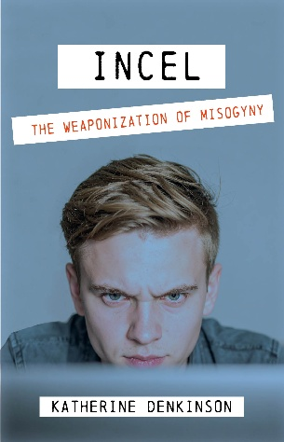

INCEL: The Weaponization of Misogyny
by Katherine Denkinson

About the book

Publication: Nov 14 2025
UK price: £14.99
US price: $19.99
ISBN PBK 978-1-0684674-1-7
Extent: 268 pages
Category: SOC051000/Violence in society/Sex and sexuality Territory: World
Publisher:
River Light Press
80 Hill Rise, London TW10 6UB Tel: 02089481427
marketing@aurorametro.com

Sales enquiries to:
rob.richardson@melia.co.uk

Review copies:
marketing@aurorametro.com
UK Orders to Central Books Ltd Freshwater Road Dagenham RM8 1RX Tel: 020 8986 4854
Fax: 020 8533 5821
orders@centralbooks.com www.centralbooks.com orders@centralbooks.com


With the rise of interest in dramas such as Netflix’s Adolescence which aired in the UK in 2025, and a spate of crimes such as the Otley Run attack in April 2025, Incel culture has become headline news. This timely and much needed book separates the fact and the fiction around Incels in an increasingly anxious national conversation.
Katherine Denkinson explores the men behind the incel subculture and the misinformation that surrounds them. ‘Incel’ has often been used as a one-size-fits-all term for a wide range of communities, from vulnerable to niche, to outright misogynist and dangerous. However, the reality is not that simple.
Incels are not cartoonish villains, but real people. The internet has been their route to communication and connection, but it has also led to them becoming mythologised. Who are these men? What are their motivations? How has our misunderstanding of this subculture made it seem even more dangerous?
This book is a must-read for all those uncertain about what the continuous spread of ‘Incel’ values and ideologies might mean. And, more importantly, what can be done to negate the very real, physical and psychological harm these online groups continue to perpetuate?

About the author
Katherine worked in the mental health arena for many years before becoming a journalist and writer. She has a strong track record of writing on Incel culture, Andrew Tate, the Far Right and online radicalization.

Her work has led to her frequent appearance as an expert commentator on these issues in national broadcasting, and in podcasts including hit podcast “Carrie Jade Does Not Exist”.

Reviews:
“A brave researcher, and an innovative and insightful observer of all the absurdities and monstrosities of social media, there are few better placed to look at the Incel movement and its many offshoots in the manosphere, than Kat Denkinson” ~ Peter Jukes, co-founder Byline Times

“Incel is as terrifying as it is necessary...a thorough, humane exploration of how violent, poisonous misogyny festers and mutates online. With compassion, clarity and years of first-hand experience, Katherine makes a powerful case for prevention over moral panic.” ~ Zoe Grunewald, Westminster Editor, The Lead

